CV Jelle Barentsz, August 2022
Basic details

Titles, Name: Prof. Dr. Jelle Barentsz (Male)
Born: 19-April-1956, Place: Renkum (NL)
Married, 3 children.

Radboudumc,
Department of Radiology and Nuclear Medicine
Huispost 766, Route 767
P.O. Box 9101 (Geert Grooteplein 10)
6500 HB Nijmegen
The Netherlands

T: +31 24 36 191 96
F: +31 24 354 08 66
M: +31 24 818 66 46
E-mail: jelle.barentsz@radboudumc.nl
Website : www.prostate-mri-barentsz.nl

Z/U number: | Z035106
Name: | J.O. Barentsz
Department: | Radiology and Nuclear Medicine
Medical specialist: | Yes | Practicing as physician: | Yes, Radiologist
MD examination | University of Utrecht (average grade 8 of 10) 29-Feb-1980
Total appointment at Radboudumc: | 1.0 fte
Date of PhD defense: | 11-Jan-1990: “MRI of Urinary Bladder cancer”
Researcher ID (obligatory) | D-3515-2009
Orchid account: 0000-0003-0366-2184 | <div itemscope itemtype="https://schema.org/Person"><a itemprop="sameAs" content="https://orcid.org/0000-0003-0366-2184" href="https://orcid.org/0000-0003-0366-2184" target="orcid.widget" rel="me noopener noreferrer" style="vertical-align:top;"><img src="https://orcid.org/sites/default/files/images/orcid_16x16.png" style="width:1em;margin-right:.5em;" alt="ORCID iD icon">https://orcid.org/0000-0003-0366-2184</a></div>
H-index (Scopus): | 81
Man-years of research | 40

Radboudumc Research Institute (mark one) |  | Radboudumc Theme (mark one)
Radboud Institute for Health Sciences | X | Urological cancers | X

Year of application | For Junior PI / PI | Awarded (yes/no)
2008 | PI | yes
2011 | PI | yes
2014 | PI | yes
2017 | PI | yes
2020 | PI | yes

Narrative
Dr. Barentsz has been a physician since 1980 and earned his doctorate in 1990. He has been Professor of Radiology since 1998 and is currently Chairman of the Radboudumc Prostate MR Reference Centre.
His research led to the introduction of 'PI-RADS' in 2012, which became the global standard for prostate MRI. His group's "4M" paper and other articles formed the basis for the amendment of the European and Dutch prostate cancer guidelines. It is now recommended to have a prostate MRI scan before a biopsy.
His work led to the "rebirth" of ferumoxtran-10 MRI, in which dextran-coated iron nanoparticles were used as MRI contrast agents for the detection of 2 mm lymph node micro metastases. An authorization trial has started in Germany, Switzerland and the Netherlands at the beginning of 2020.
Dr. Barentsz "research focuses on the following objectives
1. Implementation of PSA + prostate MRI for early detection. Use of artificial intelligence to control the quality of prostate MRI image acquisition and interpretation
2. Interactive, hands-on training at national and international level with the aim of turning radiologists into prostate MRI experts. To achieve this, he works on quality control, accreditation and certification and continues to build up a network of excellence prostate MRI
3. Enabling the worldwide marketing authorization of ferumoxtran-10 MRI and its implementation for focal radiotherapy for the treatment of lymph node micro-metastases

He is a bit stubborn when everyone goes to the right, he goes to the left when he thinks that is the best way. He is certainly decisive in this choice but is open to any good idea. E.g., urologists were against the idea of using MRI to detect prostate cancer. But he never gave up. Now, he is being honored by European urologists with the 2020 EAU Innovators in Urology Award, and by invitation he is Imaging Editor of the Executive Editorial Board of European Urology. In this latter position he tries to promote useful imaging tools that help patients. To achieve his goals, he can be quite impatient. This is due to his dedication and passion. Sometimes he forgets that changes in medical care need time. He is on the advisory board of prostate cancer patients, and often called after hours.
To this end, he and his colleagues founded the Radboudumc Prostate (MRI) Expert Centre. In this center, patients can use the latest imaging techniques: mpMRI, bpMRI, nano-MRI, combined with 18F or 68Ga-PSMA PET-CT. Patients can also receive theranostics with A- or Lu-PSMA and MR-guided focal therapies. They can consult experts from this center for questions about prostate MRI, PET-CT, theranostics and focal therapy
He is the senior author of more than 300 papers, 7 of them in the last 2 years with a high impact factor (> 15), which has inspired many enthusiastic young researchers to write outstanding articles
Awards:
- Royal Medal: Knight of the Dutch Order of Lion
- EAU Innovator in Urology Award 2020
- Honorary Member of the Japanese Radiological Society
- Honorary Member of the Polish Medical Radiological Society
- Dutch Radiology Wertheim-Salomonson Medal
- SAR Lifetime Achievement Award
- Queen Wilhelmina Research Award (€2,000,000)
- Best Scientific Paper European Urology 2017
- 3x SCBTMR Lauterbur Award
He is very active on social media despite his age: he has more than 1300 expert prostate followers on Twitter and more than 500 followers on LinkedIn. He was recently seen on national television news when he announced the introduction of prostate MRI into national guidelines
He likes to present and teach, see for yourself:
"TEDx 2012 yes, we scan." That was quite a provocative lecture for urologists.
"I have dream; I forget all the reasons why they don't come true and believe the one reason why they will.”
1. Global prostate cancer screening by PSA + MRI
2. Universal approval and use of nano- (Ferrotran®) MRI
3. Global Prostate MRI Cloud Network for Artificial Intelligence

Indicate with one “X” your position in the axis/spectrum from Molecule to Man to Population

Mol | Mol-Man | Man | Man-Pop | Pop
x | x | x | x | x

Research Group
Name | Department | Position
Henk-Jan Huisman | Radiology | UD
Maarten de Rooij | Radiology | Postdoc
Patrik Zamecnik | Radiology | PhD student
Marloes van der Leest | Radiology | PhD student
Ansje Fortuin | Radiology | PhD student
Esther Hamoen | Radiology | PhD student
Linda Thijssen | Radiology | PhD student
Marjan Nijendijk | Radiology | PA
* UHD / UD / Postdoc / PhD students (as registered in Hora Est)

International esteem
1.Board member of scientific (inter)national committee/organisation
Sci. society
Sci. committee | Richtlijn Commissie Prostaatkanker
Coordinator or WP leader of intl. consortium
Member of EU or NWO grant committee/panel
Other | Advisory Board Prostaat Kanker Stichting
2. Member of editorial board or editor of international journal with an IF > 4 (>2 for junior PI) or in subject category Q1
Editorial board | European Urology
Editor | Imaging Editor
3. Invited lecture at international top meeting
Many (>10/yearly) | RSNA, AUA, EAU, ESUR, ICIS, SAR, SCBTMR(SABI)
4. (Personal) prize or award of distinction
By science community | EAU 2020 Innovators in Urology Award  Best Scientific Paper European Urology 2017  Wertheim Salomonson Medal
By industry
By public sector
Honorary doctorate / visiting professor-ship abroad | Honorary Member Japanese Radiological Society  Honorary Member Polish Medical Radiological Society
For group member
5. (by preference personally) invited review or editorial in a prestigious journal

1. Multiparametric Magnetic Resonance Imaging for Prostate Cancer Detection: What We See and What We Miss. Anwar R. Padhani, Masoom A. Haider, Arnauld Villers, Jelle O. Barentsz. European Urology, Vol. 75, Issue 5, p721–722

2. Prostate Imaging-Reporting and Data System Steering Committee: PI-RADS v2 Status Update and Future Directions. Anwar R. Padhani, Jeffrey Weinreb, Andrew B. Rosenkrantz, Geert Villeirs, Baris Turkbey, Jelle Barentsz. European Urology, Vol. 75, Issue 3, p385–396

3. Prostate Imaging-Reporting and Data System Version 2 and the Implementation of High-quality Prostate Magnetic Resonance Imaging
Jelle Barentsz, Maarten de Rooij, Geert Villeirs, Jeffrey Weinreb. European Urology, Vol. 72, Issue 2, p189–191
4. Assessing Metastatic Disease in Advanced Prostate Cancer: It's Time to Change Imaging. Jelle O. Barentsz, Peter Mulders, Winald Gerritsen, Jurgen J. Fütterer. European Urology, Vol. 71, Issue 1, p93–95
Published online: August 30, 2016

Societal impact
- Public outreach, as expert in media, accessible to a large audience
Newspaper | De Telegraaf
Magazine | Various medical papers
Radio/TV | 30/1/2020 Radio NOS (6:30 uur); 30/1/2020 NOS Journaal: entire day
Website | Kanker.nl (specialist); www.http://www.mri-prostate-barentsz.nl/
Other | Linkedin (>500 followers), Twitter (>1000 expert-followers)
- Author of manual for professionals, of policy formulated document, of policy instrument relating to healthcare or of guideline or quotation in guideline
Clinical guideline | Module diagnostiek locale prostaat van de NVU Multidisciplinaire Richtlijn Prostaatkanker
Policy document/
instrument
Consultancies
Other
- Board member of important public (societal) organization
Public org. | Advisory Board Prostaat Kanker Stichting
Societal (paid) ancillary position
Other
- Wide and established implementation of product in health care and health care market
Patent
License
Spin-off | Ferrotran (nano-MRI contrast agent), MR-manipulator (biopsy-robot)
Contract with private partners | Advisor SPL Medical  Advisor Soteria Medical
- Teaching activities
For BSc or MSc curricula
For professionals or general public | Yearly >10 (Inter)national interactive workshops and key-note lectures  Most challenging: PI-RADS Workshop @ RSNA 2019 (interactive hands-on-workshop with Cloud-based workstation for >500 attendees)

Publications: (2022-04-20)
# 341; h-factor: 81 (Scopus)

See: http://www.mri-prostate-barentsz.nl/439673309

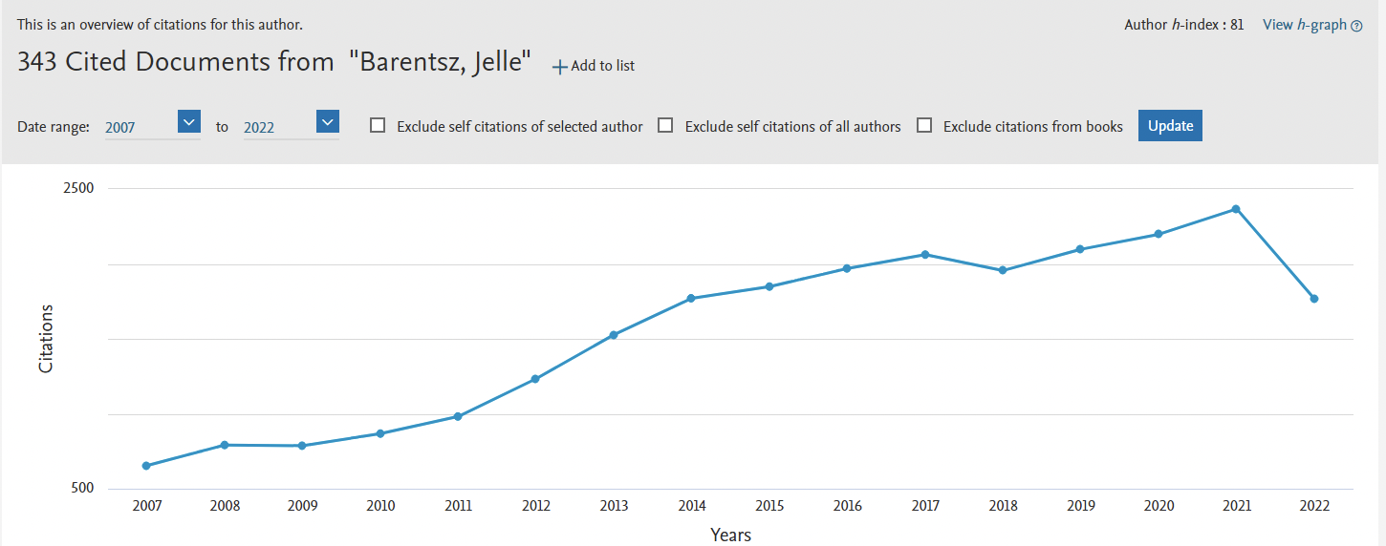

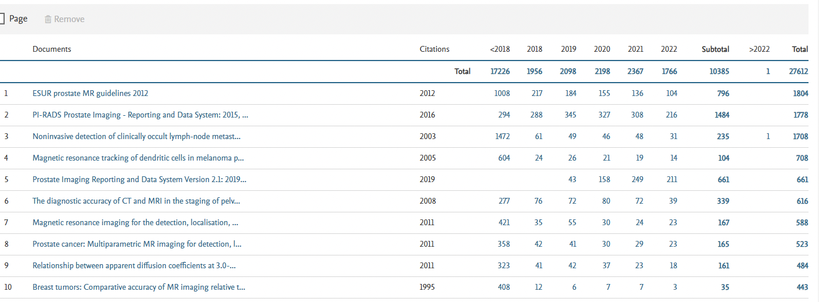

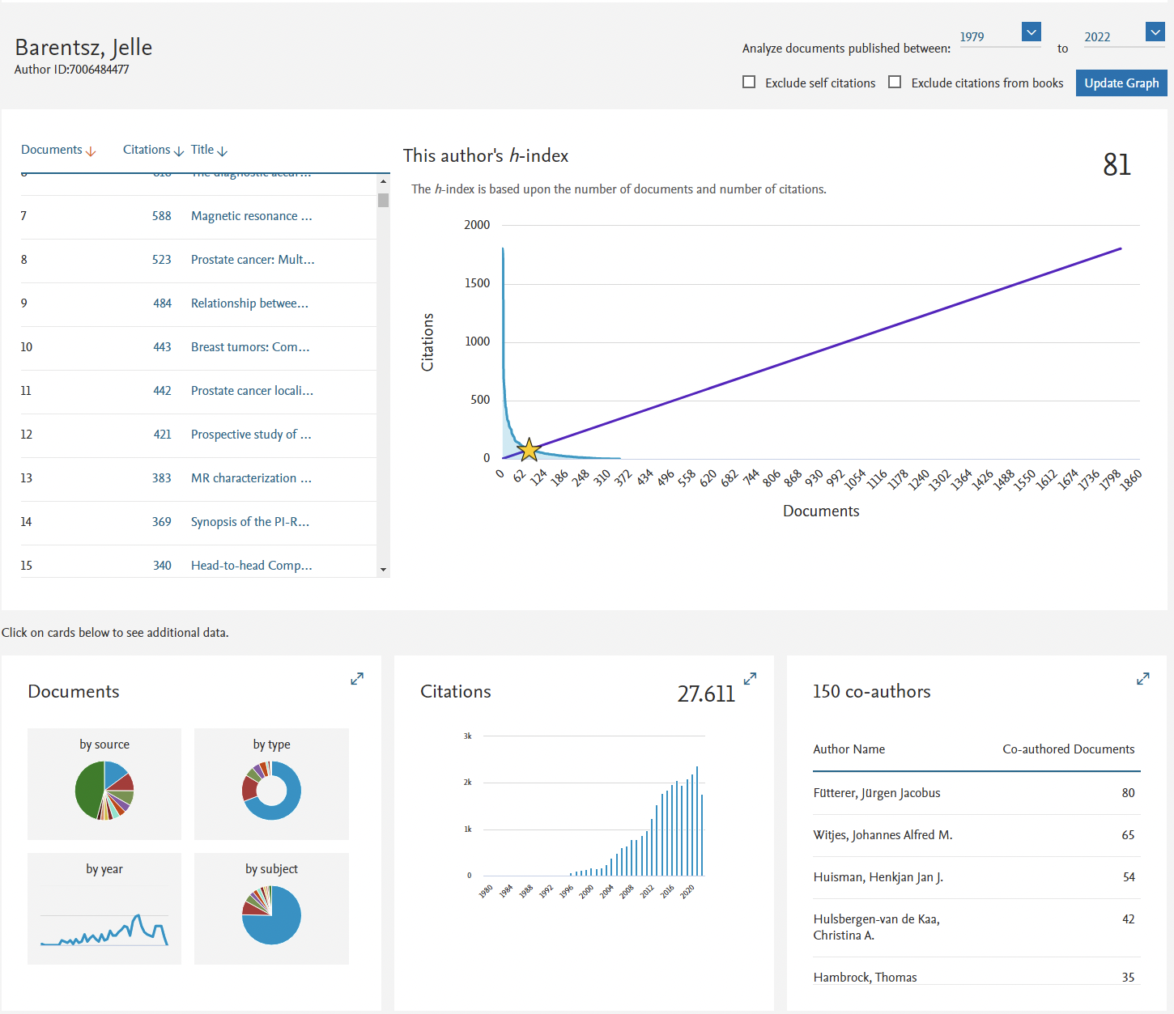

Book(chapters)

Book:

Magnetic Resonance Imaging of Carcinoma of the Urinary Bladder. Barentsz JO, Debruyne F, and Ruijs JHJ edts. Kluwer Academic Publishers 1st edition 1990.

Book chapters:

Grainger & Allison Diagnostic Radiology. Adam, Dixon, Gillard, Schaefer-Prokop edts. Chuchill Livingstone, 5th Edition 2008. Ch 39: p 931. Bomers, Bittencourt, Villeirs, Barentsz.

Oncologie. Van der Velde, van der Graaf, van Krieken, Marijnen, Vermorken edts. Bohn Stafleu van Loghum, Houten. 8th Edition. 2011. Ch 4: p103. Diagnostiek in de oncologie. Vermorken, Schrijvers, Weyler, Moreels, Carp, Barentsz, Heijmink.

Nanoparticles in Biomedical Imaging: Emerging Technologies and Applications. Bulte, Modo, Edts. Springer. 1st Edition. 2008. Ch 3: p25 Use of USPIO’s for Clinical Lymph Node Imaging. Barentsz and Tekkis.

Nuclear Oncology. C Aktolun an SJ Goldsmith edts. Wolters. 1st edition. 2015. Ch 27: p399. Assessment of Lymph Node Detection and Imaging in Oncology. AS Fortuin, TC Kwee, S Bassu, et al (JO Barentsz before last author).

Clinical Urography. HM Pollack and BL McClennan edts. Saunders. 2nd ed. 2000. Ch 48: p1642 Bladder Cancer. JO Barentsz.

Top Cited 10 Papers

Selection of 10 highest IF Scientific Papers

Barentsz J.O. (31-Jan-2022)

- Immerzeel, J., Israël, B., Schoots, I.G., van Basten, J.P., Kurth, K.H., de Reijke, Th., Sdelaar, M., Debruyne, F., Barentsz, J. O.
Multiparametric Magnetic Resonance Imaging for the Detection of Clinically Significant Prostate Cancer: What Urologists Need to Know. Part 4: Transperineal MRI biopsy.
(2022) European Urology, 81(1), pp.110-117. (IF 23.4)
https://doi.org/10.1016/j.eururo.2021.10.032

- Engels, R.R.M., Israël, B., Padhani, A.R., Barentsz, J.O.
Multiparametric Magnetic Resonance Imaging for the Detection of Clinically Significant Prostate Cancer: What Urologists Need to Know. Part 1: Acquisition
(2020) European Urology, 77 (4), pp. 457-468.
https://www.scopus.com/inward/record.uri?eid=2-s2.0-85072695115&doi=10.1016%2fj.eururo.2019.09.021&partnerID=40&md5=f909a7407cd9ddb48a59390d501fe7d9 (IF: 23.4)
DOI: 10.1016/j.eururo.2019.09.021

- Israël, B., Leest, M.V.D., Sedelaar, M., Padhani, A.R., Zámecnik, P., Barentsz, J.O.
Multiparametric Magnetic Resonance Imaging for the Detection of Clinically Significant Prostate Cancer: What Urologists Need to Know. Part 2: Interpretation
(2020) European Urology, 77 (4), pp. 469-480.
https://www.scopus.com/inward/record.uri?eid=2-s2.0-85076232806&doi=10.1016%2fj.eururo.2019.10.024&partnerID=40&md5=7ab8172cb015ff67eb6e0c4fd3f485c3 (IF: 23.4)
DOI: 10.1016/j.eururo.2019.10.024

- Venderink, W., Bomers, J.G., Overduin, C.G., Padhani, A.R., de Lauw, G.R., Sedelaar, M.J., Barentsz, J.O.
Multiparametric Magnetic Resonance Imaging for the Detection of Clinically Significant Prostate Cancer: What Urologists Need to Know. Part 3: Targeted Biopsy
(2020) European Urology, 77 (4), pp. 481-490.
https://www.scopus.com/inward/record.uri?eid=2-s2.0-85076224463&doi=10.1016%2fj.eururo.2019.10.009&partnerID=40&md5=c5a70d69e759e7b95c696d961337a7eb (IF: 23.4)
DOI: 10.1016/j.eururo.2019.10.009

- van der Leest, M., Israël, B., Cornel, E.B., Zámecnik, P., Schoots, I.G., van der Lelij, H., Padhani, A.R., Rovers, M., van Oort, I., Sedelaar, M., Hulsbergen-van de Kaa, C., Hannink, G., Veltman, J., Barentsz, J.
High Diagnostic Performance of Short Magnetic Resonance Imaging Protocols for Prostate Cancer Detection in Biopsy-naïve Men: The Next Step in Magnetic Resonance Imaging Accessibility
(2019) European Urology, 76 (5), pp. 574-581.
https://www.scopus.com/inward/record.uri?eid=2-s2.0-85066408465&doi=10.1016%2fj.eururo.2019.05.029&partnerID=40&md5=dd8ca18c62d8233cab89fc1055d6e1f7 (IF: 23.4)
DOI: 10.1016/j.eururo.2019.05.029

- Turkbey, B., Rosenkrantz, A.B., Haider, M.A., Padhani, A.R., Villeirs, G., Macura, K.J., Tempany, C.M., Choyke, P.L., Cornud, F., Margolis, D.J., Thoeny, H.C., Verma, S., Barentsz, J.*, Weinreb, J.C.* (*co-senior authors)
Prostate Imaging Reporting and Data System Version 2.1: 2019 Update of Prostate Imaging Reporting and Data System Version 2
(2019) European Urology, 76 (3), pp. 340-351.
https://www.scopus.com/inward/record.uri?eid=2-s2.0-85063010991&doi=10.1016%2fj.eururo.2019.02.033&partnerID=40&md5=78b9cf24f467479a0bdff0dac543f0d9 (IF: 23.4)
DOI: 10.1016/j.eururo.2019.02.033

- van der Leest, M., Cornel, E., Israël, B., Hendriks, R., Padhani, A.R., Hoogenboom, M., Zamecnik, P., Bakker, D., Setiasti, A.Y., Veltman, J., van den Hout, H., van der Lelij, H., van Oort, I., Klaver, S., Debruyne, F., Sedelaar, M., Hannink, G., Rovers, M., Hulsbergen-van de Kaa, C., Barentsz, J.O.
Head-to-head Comparison of Transrectal Ultrasound-guided Prostate Biopsy Versus Multiparametric Prostate Resonance Imaging with Subsequent Magnetic Resonance-guided Biopsy in Biopsy-naïve Men with Elevated Prostate-specific Antigen: A Large Prospective Multicenter Clinical Study
(2019) European Urology, 75 (4), pp. 570-578.
https://www.scopus.com/inward/record.uri?eid=2-s2.0-85056988132&doi=10.1016%2fj.eururo.2018.11.023&partnerID=40&md5=867f9cdd496f730b31a1822c6d3238eb (IF: 23.4)
DOI: 10.1016/j.eururo.2018.11.023

- Padhani, A.R., Weinreb, J., Rosenkrantz, A.B., Villeirs, G., Turkbey, B., Barentsz, J.
Prostate Imaging-Reporting and Data System Steering Committee: PI-RADS v2 Status Update and Future Directions
(2019) European Urology, 75 (3), pp. 385-396. Cited 50 times.
https://www.scopus.com/inward/record.uri?eid=2-s2.0-85048333286&doi=10.1016%2fj.eururo.2018.05.035&partnerID=40&md5=550722d6ebcb558458d9b1d9dca7839a (IF: 23.4)
DOI: 10.1016/j.eururo.2018.05.035

- Weinreb, J.C.*, Barentsz, J.O.*, Choyke, P.L., Cornud, F., Haider, M.A., Macura, K.J., Margolis, D., Schnall, M.D., Shtern, F., Tempany, C.M., Thoeny, H.C., Verma, S. (*co-first author).
PI-RADS Prostate Imaging - Reporting and Data System: 2015, Version 2
(2016) European Urology, 69 (1), pp. 16-40.
https://www.scopus.com/inward/record.uri?eid=2-s2.0-84955708702&doi=10.1016%2fj.eururo.2015.08.052&partnerID=40&md5=3029f9e3b1fb0ed156e35039cc91203c (IF: 23.4)
DOI: 10.1016/j.eururo.2015.08.052

- Barentsz, J.O., Richenberg, J., Clements, R., Choyke, P., Verma, S., Villeirs, G., Rouviere, O., Logager, V., Fütterer, J.J.
ESUR prostate MR guidelines 2012
(2012) European Radiology, 22 (4), pp. 746-757.
https://www.scopus.com/inward/record.uri?eid=2-s2.0-84861455749&doi=10.1007%2fs00330-011-2377-y&partnerID=40&md5=6aceb6dba71e77abf5703ac20f9a7fba (IF: 6.3)
DOI: 10.1007/s00330-011-2377-y

- Harisinghani, M.G.,* Barentsz, J.*, Hahn, P.F., Deserno, W.M., Tabatabaei, S., Van de Kaa, C.H., De la Rosette, J., Weissleder, R.(*co first-author)
Noninvasive detection of clinically occult lymph-node metastases in prostate cancer
(2003) New England Journal of Medicine, 348 (25), pp. 2491-2499.
https://www.scopus.com/inward/record.uri?eid=2-s2.0-0038469746&doi=10.1056%2fNEJMoa022749&partnerID=40&md5=f9a9744710f02b791b94ce4e9284eaae (IF: 91.9)
DOI: 10.1056/NEJMoa022749

All Papers (Pub Med)
https://pubmed.ncbi.nlm.nih.gov/?term=Barentsz+J+%5BAU%5D&sort=date&size=200

Personal obtained funding

Concerning the period January 1st, 2015 –December 31st, 2019

Title project (abbreviated) | Role:  Main applicant/  Co-applicant/  WP leader/other | Year granted | Funding body | K €  total  grant | K €  Radboud-umc part
1. MAGNIFI | Main Applicant | 2016-ongoing | Wesly Medical Research Institute (Brisbane)  and Garvan Research Institute (Sydney) | 126.8 | 126.8
2.ROF 1835 VALINODE | Main Applicant | 2019 | Radbopud Oncologie Fonds (KWF) | 149.5 | 149.5
3. ROF 1906 AI | Co-appliocant | 2019 | Radbopud Oncologie Fonds (KWF) | 40 | 40
4. ROF 2003 THERANOSTICS | Co-applicant | 2019 | Radbopud Oncologie Fonds (KWF) | 50 | 50

Personal obtained funding

Concerning the period January 1st, 2012 –December 31st, 2016

Title project (abbreviated) | Co-applicant research leader(s) | Year granted | Funding body | K €  (total grant)
1. Value of Multi-parametric MRI and MR-guided biopsies the detection of  significant prostate cancer in men with an elevated PSA 2016-2018. | J.O. Barentsz (PI)  J. Witjes  M. Rovers  C Hulsbergen-vd Kaa | 2015 | KWF  2015-6707 | 1.241
2. ZON-MW: Value of CT versus MRI using USPIO in the detection of lymph node metastases in prostate cancer  3. KWF: Detection of prostate cancer based on contrast enhanced imaging of hemodynamic changes in the prostate.  4. KWF: Vascular effects of VEGF mutations: implications for MRI of human tumors. R. De Waal  5. KWF: Contrast enhanced MRI and US of prostate cancer  6. KWF: Computer assisted diagnoses of prostate cancer combining high resolution, dynamic contrast enhanced and spectroscopic MR  7. KWF Queen Wilhelmina Program Award - Exploring the clinical value of novel high resolution anatomic, molecular and functional MR imaging in prostate cancer | J.O. Barentsz  J O Barentsz  A. Heerschap  J.O. Barentsz  J.O. Barentsz  HJ Huisman  JO Barents  JA Witjes  JO Barentsz  A Heerschap | 2002-2005  2003-2007  2000-2004  1998-2004  2004-2008  2008-2014 | ZON-MW  Doelmatigheid  KWF  KWF  KWF  KWF  KWF | 1.200  250  250  250  250  2.000

PhD theses supervised as (co-)promotor: 36 (+8 “to go”)

PhD student | Title thesis | Promotor (yes/no) | Co-promotor (yes/no) | Date of PhD defense
W. Morshuis | Surgical treatment of pectus excavatum. Indications and results | N | Y | 1994
PEJM Sallevelt | De substitutiewaarde van MRI inzake de preoperatieve diagnostiek van het Abdominale Arteriosclerotische Aneurysma. | N | Y | 1994
C Boetes | MR imaging in breast cancer, a clinical study | N | Y | 1995
D Franssen-Franken | Homocysteinaemie, treatment with vitamine D and folowup with MRI / MRA. | N | Y | 1996
PBJ van Vierzen | Fast Dynamic MRI of Gynecological Tumors | N | Y | 1997
AE Holland | Clinical and Experimental Cardiovascular MRA | Y | N | 2000
JW Goldfarb | Gd-enhanced MRI: Technical developments and Clinical Testing | Y | N | 2000
E Bos | Clinical Value of Analytes in Cyst Fluid from Ovarian Tumors | Y | N | 2003
M Engelbrecht | Local Staging of PCa using MRI | Y | N | 2003
JJ Futterer | Advanced MRI Techniques in Localising and Local Staging of PCa. | Y | N | 08-02-06
A Hovels | The Value of MR-Lymphography in the Detection of Lymph Nodal Metastasis in Patients with PCa. | Y | N | 10-02-08
S Broekhuis | Dynamic MRI in Female Pelvic Floor Disorders | Y | N | 10-03-2010
WMLLG Deserno | New Horizons in Lymph Node Imaging in Oncology | Y | N | 22-12-2010
J Veltman | Dynamic Contrast Enhanced MRI in the Classification of Breast Lesions | Y | N | 11-10-2010
RM Mann | The Effectiveness of Breast MRI in Invasive Lobular Carcinoma | Y | N | 24-11-2010
H Meijer | Magnetic resonance lymphography and lymph node irradiation in prostate cancer | Y | N
MJ Stoutjesdijk | Automated Analysis of Contrast Enhancement in MRI of the Breast | Y | N | 16-11-2011
PC Vos | Computer-aided Diagnosis of PCa with MRI | Y | N | 08-12-2011
C Meeuwis | Computer Aided Detection and Guided Biopsies using 3T MRI | Y | N | 27-09-2011
R Heesakkers | MR-lymphography in Prostate cancer | Y | N | 25-01-2012
T Hambrock | The value of 3T MRI for the Diagnosis and Aggressiveness Assessment of prostate cancer | Y  Cum Laude | N | 04-12-2012
D. Yakar | MRI in localizing prostate Cancer (recurrence) and guided interventions | Y | N | 04-12-2012
D. Somford | Challenges in the diagnosis, grading and staging of prostate cancer | Y | N | 26-09-2013
C. Hoeks | Multiparametric MR imaging and MR guided biopsy: prostate cancer diagnosis and risk-stratification | Y | N | 04-10-2013
G Litjens | Computerized detection of cancer in multi-parametric prostate MRI | Y | N | 23-01-2015
S Heijmink | MR Imaging of Prostate Cancer at 3T: the Pros and Cons of Scanning with Endorectal Coil | Y | N | 24-06-2015
PhD theses supervised as (co-)promotor: 36 + 6 Candidates

PhD student | Title thesis | Promotor (yes/no) | Co-promotor (yes/no) | Date of PhD defense
W. Morshuis | Surgical treatment of pectus excavatum. Indications and results | N | Y | 1994
PEJM Sallevelt | De substitutiewaarde van MRI inzake de preoperatieve diagnostiek van het Abdominale Arteriosclerotische Aneurysma. | N | Y | 1994
C Boetes | MR imaging in breast cancer, a clinical study | N | Y | 1995
D Franssen-Franken | Homocysteinaemie, treatment with vitamine D and folowup with MRI / MRA. | N | Y | 1996
PBJ van Vierzen | Fast Dynamic MRI of Gynecological Tumors | N | Y | 1997
AE Holland | Clinical and Experimental Cardiovascular MRA | Y | N | 2000
JW Goldfarb | Gd-enhanced MRI: Technical developments and Clinical Testing | Y | N | 2000
E Bos | Clinical Value of Analytes in Cyst Fluid from Ovarian Tumors | Y | N | 2003
M Engelbrecht | Local Staging of PCa using MRI | Y | N | 2003
JJ Futterer | Advanced MRI Techniques in Localising and Local Staging of PCa. | Y | N | 08-02-06
A Hovels | The Value of MR-Lymphography in the Detection of Lymph Nodal Metastasis in Patients with PCa. | Y | N | 10-02-08
S Broekhuis | Dynamic MRI in Female Pelvic Floor Disorders | Y | N | 10-03-2010
WMLLG Deserno | New Horizons in Lymph Node Imaging in Oncology | Y | N | 22-12-2010
J Veltman | Dynamic Contrast Enhanced MRI in the Classification of Breast Lesions | Y | N | 11-10-2010
RM Mann | The Effectiveness of Breast MRI in Invasive Lobular Carcinoma | Y | N | 24-11-2010
H Meijer | Magnetic resonance lymphography and lymph node irradiation in prostate cancer | Y | N
MJ Stoutjesdijk | Automated Analysis of Contrast Enhancement in MRI of the Breast | Y | N | 16-11-2011
PC Vos | Computer-aided Diagnosis of PCa with MRI | Y | N | 08-12-2011
C Meeuwis | Computer Aided Detection and Guided Biopsies using 3T MRI | Y | N | 27-09-2011
R Heesakkers | MR-lymphography in Prostate cancer | Y | N | 25-01-2012
T Hambrock | The value of 3T MRI for the Diagnosis and Aggressiveness Assessment of prostate cancer | Y  Cum Laude | N | 04-12-2012
D. Yakar | MRI in localizing prostate Cancer (recurrence) and guided interventions | Y | N | 04-12-2012
D. Somford | Challenges in the diagnosis, grading and staging of prostate cancer | Y | N | 26-09-2013
C. Hoeks | Multiparametric MR imaging and MR guided biopsy: prostate cancer diagnosis and risk-stratification | Y | N | 04-10-2013
G Litjens | Computerized detection of cancer in multi-parametric prostate MRI | Y | N | 23-01-2015
S Heijmink | MR Imaging of Prostate Cancer at 3T: the Pros and Cons of Scanning with Endorectal Coil | Y | N | 24-06-2015
E Vos | Magnetic resonance imaging of prostate cancer: assessment of aggressiveness and pre-clinical developments | Y | N | 01-05-2016
W van de Ven | MRI guided TRUS prostate biopsy - a viable alternative? | Y | N | 04-07-2016
M Hoogenboom | MRI guided HiFu | Y | N | 07-03-2017
J Bomers | MR-guided focal therapy in patients with localized recurrent prostate cancer | Y | N | 06-06-2017
M. Schouten | MRI-guided prostate biopsy: which direction? | Y | N | 19-07-2017
K. Overduin | MRI-guided interventions for fast diagnosis and focal treatment of (recurrent) prostate cancer | Y | N | 18-12-2017
M de Rooij | Multiparametric MRI in prostate cancer | Y | N | 06-07-2017
W. Venderink | MRI and MRI-targeted biopsy of the prostate. The role of direct in-bore and MRI US fusion guided biospy | Y |  | 11-12-2018
Oscar Debats | Magnetic Resonance Lymphography | Y | N | 01-10-2020
Bart Philips | Methodological development of multiparametric, multimetabolic and USPIO-enhanced MRI at 7 Tesla for characterizing and staging prostate cancer | Y | N | 27-10-2020
Candidates

Patrik Zamecnik |  | Y | N | 2022
Marloes van der Leest |  | Y | N | 2022
Bas Israel |  | Y | N | 2023
Linda Thijssen |  | Y | N | 2025
Ansje Fortuin |  | Y | N | 2023
Esther Hamoen |  | Y | N | 2023

